## **Issues List**

1. **Issues Title: Add Project**

**Issues Title:** Add Project with Only Space

**Reproducing Steps:** Only space must not accept as a project title**.**

**Priority:** High

**Issue Image:**

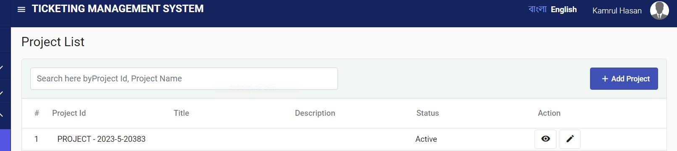

1. **Issues Title: Add Project**

**Issues Title:** Add Project with Only Numeric or Special Characters

**Reproducing Steps:** Only numeric or special characters should not accept as a project   
 title. It’s nice to have a meaningful title according to project.

**Priority:** Medium

**Issue Image:**

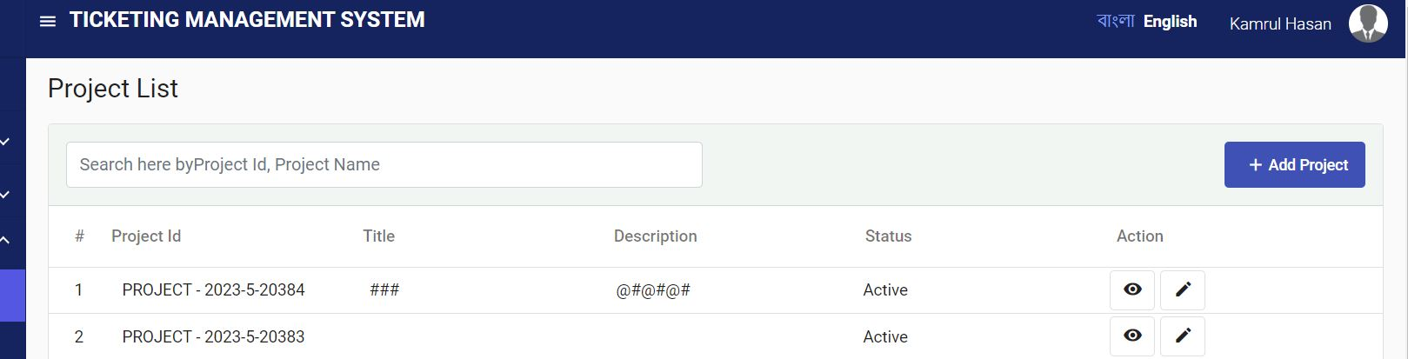

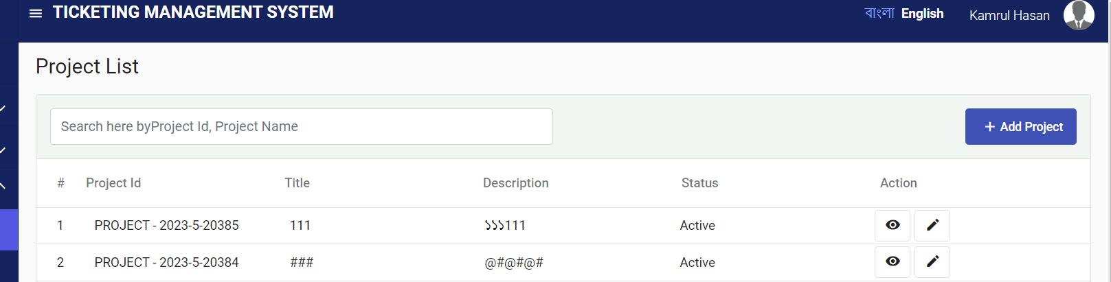

1. **Issues Title: Add Project**

**Issues Title:** Add Project with a Single Character

**Reproducing Steps:** Only single characters should not accept as a project title. It’s nice   
 to have a meaningful title according to project.

**Priority:** Low

**Issue Image:**

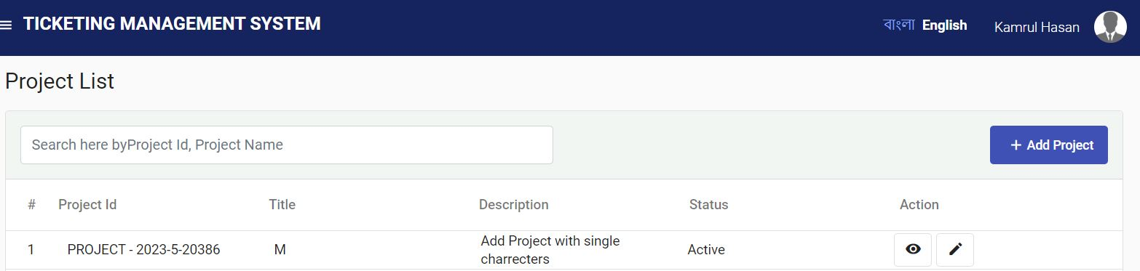

1. **Issues Title:** **Add Project**

**Issues Title:** Add Project with Title Language Shuffle  
**Reproducing Steps:** Title (Bangla) should not accept English Language & vice versa.   
 It’s nice to have language restriction according to title language.

**Priority:** Medium

**Issue Image:**

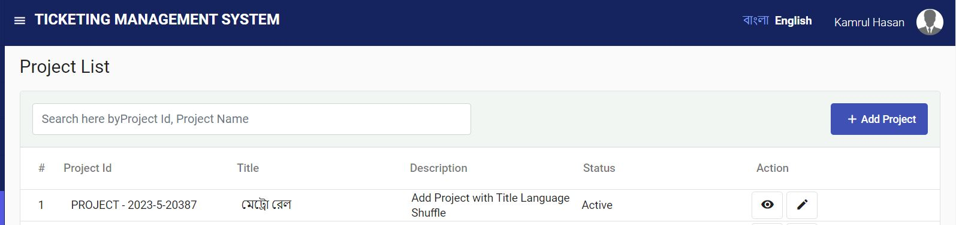

1. **Issues Title: Add Project**

**Issues Title:** Add Project with Title (Both) in Bangla

**Reproducing Steps:** Title (English) should not accept Bangla Language. It’s nice to   
 have language restriction according to title language.

**Priority:** Medium

**Issue Image:**

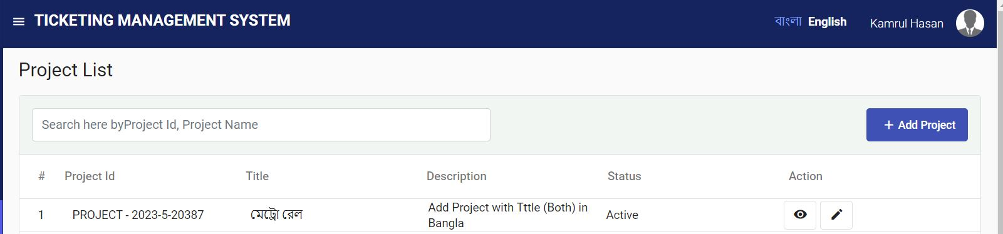

1. **Issues Title: Add Project**

**Issues Title:** Add Project with Title (Both) in English

**Reproducing Steps:** Title (Bangla) should not accept English Language. It’s nice to   
 have language restriction according to title language.

**Priority:** Medium

**Issue Image:**

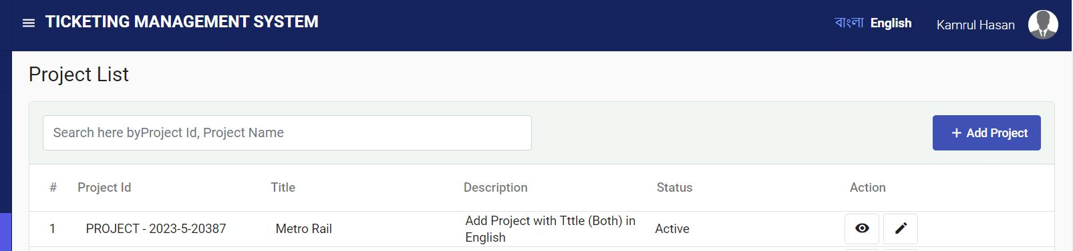

1. **Issues Title: Add Project**

**Issues Title:** Add Duplicate Project Title

**Reproducing Steps:** Whenadd a duplicate project title, it shows a garbage value in title   
 and also inactive the project. Title must be unique otherwise user   
 should not add project.

**Priority:** High

**Issue Image:**

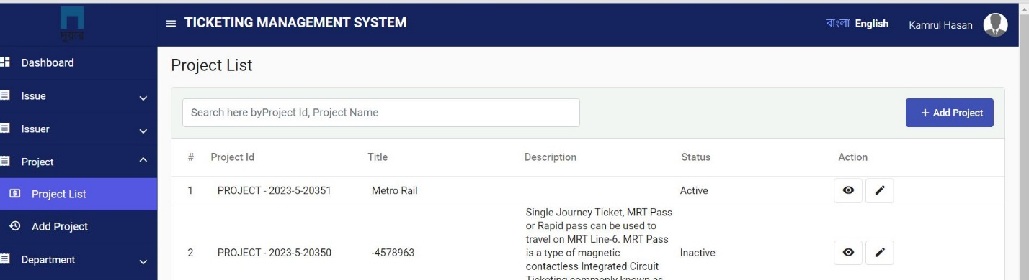

1. **Issues Title: Edit Project**

**Issues Title:** Edit Project Confirmation

**Reproducing Steps:** When a project Information is edited, it notifies with a confirmation   
 message. Confirmation message should be like "**Project has been   
 changed or updated successfully**". But it shows "Project has been   
 added successfully".

**Priority:** Low

**Issue Image:**

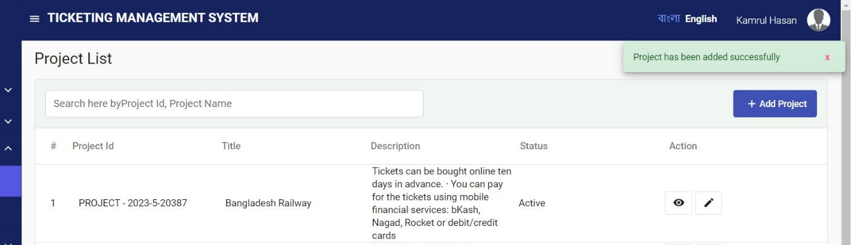

1. **Issues Title: Edit Project**

**Issues Title:** Placeholder Text

**Reproducing Steps:** Placeholder should be according to the field name. In Status field,   
 the place holder should be “Enter Project Status” but it shows “Enter   
 project Title in English”.

**Priority:** Low

**Issue Image:**

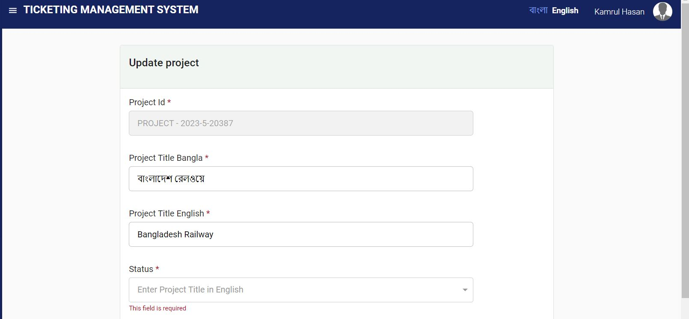

1. **Issues Title: Edit Project**

**Issues Title:** Mandatory Field

**Reproducing Steps:** Description field is marked as mandatory field but it's not a   
 mandatory field. User can edit project without providing   
 description**.**

**Priority:** Low

**Issue Image:**

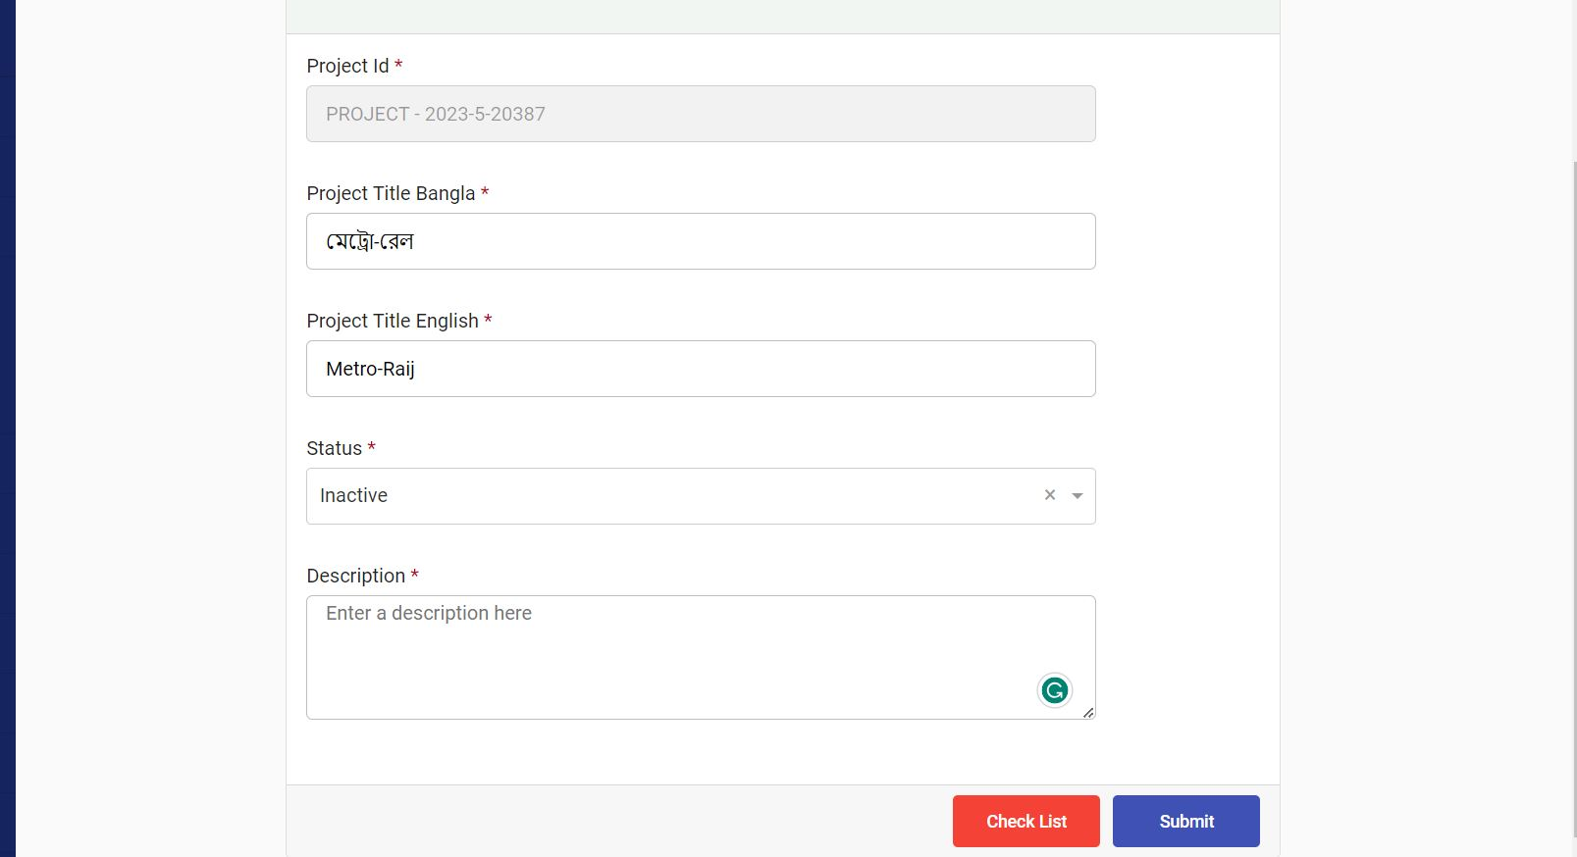

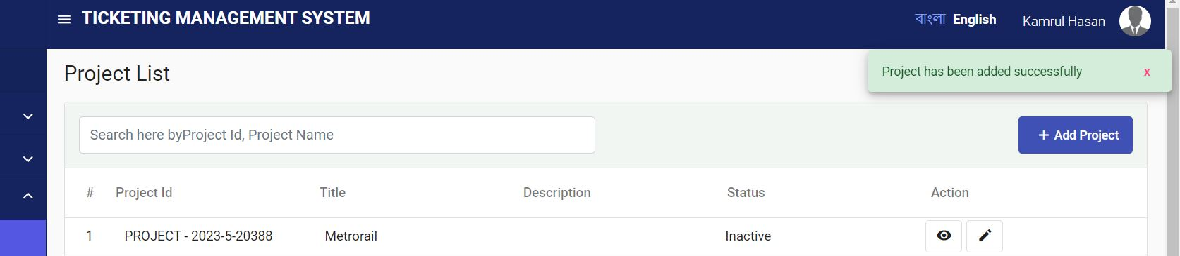

1. **Issues Title: Edit Project**

**Issues Title:** Submit Button Name

**Reproducing Steps:** In Edit option, button name is "Submit", It's a generic name for a   
 button. It's nice to have name "Update"

**Priority:** Low

**Issue Image:**

